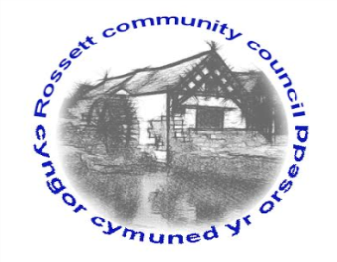

Rossett Community Council

12th October 2018

The next meeting of Rossett Community Council is to be held at Rossett Village Hall back room, Station Road, Rossett on Wednesday 17th October 2018 at 7.30pm to transact the following business.

Yours faithfully

Wendy Pace
Clerk for the Council

AGENDA

Declarations of Interest
Members are reminded that they should declare the existence and nature of any personal or prejudicial interest in the business of this meeting.

- Apologies for absence.

- Approval of the Minutes of the 19th September 2018 meeting.

- Police Report.
    - Community Speed Watch - Clerk
4. Representation's from General Public

5. Matters arising:
- Burton CCTV

7. Matters to be discussed:
- Rossett Village Festival – Cllr Fortune
- Remembrance Parades – Clerk

8. Reports : To receive updates from the following:
- County Councillor Jones’ Report
- Clerk’s Report
- Reports from Community Councillors

9. Planning:

P/2018/0852 – Brookfield, Burton Green – Two-Storey Rear Extension

10. Finance:
- Finance Report
- Invoices payable (see attached schedule)
- External Audit
- Donation Budget

11. Other Items brought to the Council’s Attention by Councillors

12. Date, Venue and Time of next meeting: Wednesday 21st November 2018 at 7.30pm at Rossett Presbyterian Church meeting room, Station Road.
_____________________________________________________________
Clerk : Wendy Pace : clerk@rossettcommunitycouncil.cymru
Telephone: 07421 261118

