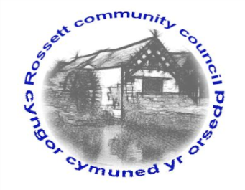
r

Rossett Community Council

12th September 2018

The next meeting of Rossett Community Council is to be held at Rossett Presbyterian Church meeting room, Station Road, Rossett on Wednesday 19th September 2018 at 7.30pm to transact the following business.

Yours faithfully

Wendy Pace
Clerk for the Council

AGENDA

Declarations of Interest
Members are reminded that they should declare the existence and nature of any personal or prejudicial interest in the business of this meeting.

- Apologies for absence.

- Approval of the Minutes of the 15th August 2018 meeting.

- Police Report.
    - Community Speed Watch - Clerk
4. Representation's from General Public

5. Matters arising:
- Cadwyn Clwyd
- Station Road (Burton Close) parking
- Wrexham Public Rights of Way Improvement Plan
- Digital Trail App – Cllr Pretsell
- Christmas Event

7. Matters to be discussed:
- Poo Bags, Gresford – Cllr Pretsell
- Remembrance Parades – Clerk

8. Reports : To receive updates from the following:
- County Councillor Jones’ Report
- Clerk’s Report
- Reports from Community Councillors

9. Planning:

P/2018/0685 – East View, Cobblers Lane, Burton – Steel Portal Framed Agricultural Livestock Building

P/2018/0706 – Kinross, Rosemary Lane, Burton – Single-Storey Side Extension

P/2018/0717 – Inglenook, Burton Road, Burton – Erection of Single Storey Side/Rear Extension following Demolition of Existing Out Riggers

P/2018/0736 – Alyn Cottage, Chester Road, Rossett – Work to Trees in Conservation Area

P/2018/0746 – Huskissons House, Chester Road, Lavister – Work to Trees Subject to Tree Preservation Order

P/2018/0776 – Lodge Farm, Off Borras Road, Commonwood – Change of Use of Land from Agriculture to a Mixed Use for Agricultural and Practice Firing Range in Association with Field and Falcon Gun Shop and Gunsmiths

10. Finance:
- Finance Report
- Invoices payable (see attached schedule)

11. Other Items brought to the Council’s Attention by Councillors

12. Date, Venue and Time of next meeting: Wednesday 17th October 2018 at 7.30pm at Rossett Village Hall back room, Station Road.
_____________________________________________________________
Clerk : Wendy Pace : clerk@rossettcommunitycouncil.cymru
Telephone: 07421 261118

