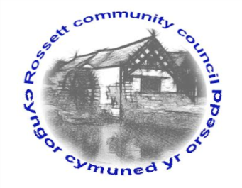

Rossett Community Council

13th December 2018

The next meeting of Rossett Community Council is to be held at Rossett Village Hall back room, Station Road, Rossett on Wednesday 19th December 2018 at 7.30pm to transact the following business.

Yours faithfully

Wendy Pace
Clerk for the Council

AGENDA

Declarations of Interest
Members are reminded that they should declare the existence and nature of any personal or prejudicial interest in the business of this meeting.

- Apologies for absence.

- Approval of the Minutes of the 21st November 2018 meeting

- Police Report.
    - Community Speed Watch - Clerk
4. Representation's from General Public

5. Matters arising:
- Burton CCTV
- Community Defibrillator

6. Matters to be discussed:
- Village Festival – Cllr Parrington
- Community Hub – Cllr Parrington

7. Reports : To receive updates from the following:
- County Councillor Jones’ Report
- Clerk’s Report
- Reports from Community Councillors

8. Planning:

P/2018/1005 – Willows End, Harwoods Lane, Rossett – Single-Storey Front and Side Extensions

P/2018/1038 – Darland Groves, Darland Lane, Rossett – Two-Storey Extension to Rear

Pre-Submission Consultation – The erection of up to 77 dwellings, public open space and vehicular access on land off Chester Road, Lavister

9. Finance:
- Finance Report
- Invoices payable (see attached schedule)
- Donation Application
- Precept

10. Other Items brought to the Council’s Attention by Councillors

11. Date, Venue and Time of next meeting: Wednesday 16th January 2019 at 7.30pm at Rossett Presbyterian Church meeting room, Station Road.
_____________________________________________________________
Clerk : Wendy Pace : clerk@rossettcommunitycouncil.cymru
Telephone: 07421 261118

