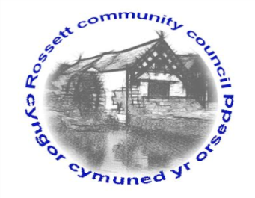

Rossett Community Council

15th November 2018

The next meeting of Rossett Community Council is to be held at Rossett Presbyterian Church meeting room, Station Road, Rossett on Wednesday 21st November 2018 at 7.30pm to transact the following business.

Yours faithfully

Wendy Pace
Clerk for the Council

AGENDA

Declarations of Interest
Members are reminded that they should declare the existence and nature of any personal or prejudicial interest in the business of this meeting.

- Apologies for absence.

- Approval of the Minutes of the 17th October 2018 meeting.

- Police Report.
    - Community Speed Watch - Clerk
4. Representation's from General Public

5. Matters arising:
- Co-option of Councillor
- Burton CCTV
- Review of Electoral Arrangements

6. Matters to be discussed:
- Community Defibrillator – Cllr Jones

7. Reports : To receive updates from the following:
- County Councillor Jones’ Report
- Clerk’s Report
- Reports from Community Councillors

8. Planning:

P/2018/0883 – Allington Farm, Broad Lane, Trevalyn – Rear Two-Storey and Single-Storey Extensions and Re-modelling Works

P/2018/0888 – Broad Oak Farm, Llyndir Lane, Rossett – Change of Use and Conversion of Barns to 10 No. Residential Units Including Demolition, New Build Parking Barns, Access and Parking Arrangements

P/2018/0889 – Hansels Mead, Chapel Lane, Rossett – Continued Parking and Operation of 1 No. Private Hire Vehicle (Previously Granted Temporary Permission)

P/2018/0897 – Ashfield, 95 Harwoods Lane, Rossett – Two-Storey Extension and Conversion of Utility Room to Garden Room with Bay

P/2018/0904 – Three Acres, Rosemary Lane, Burton – Application for Variation of Condition 2 Imposed Under Planning Permission P/2017/0676 To Vary Design of Extensions to Northern and Eastern Aspects of the Dwelling

P/2018/0907 – The Chapel, Chester Road, Rossett – Removal of Existing Hedge Extension and Increase in Height to Existing Wall and Installation of Roller Shutter Security Doors

9. Finance:
- Finance Report
- Invoices payable (see attached schedule)
- Donation Applications

10. Other Items brought to the Council’s Attention by Councillors

11. Date, Venue and Time of next meeting: Wednesday 19th December 2018 at 7.30pm at Rossett Village Hall, back room, Station Road.
_____________________________________________________________
Clerk : Wendy Pace : clerk@rossettcommunitycouncil.cymru
Telephone: 07421 261118

