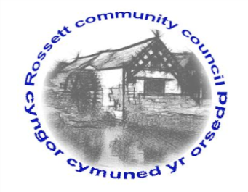

Rossett Community Council

11th January 2019

The next meeting of Rossett Community Council is to be held at Rossett Presbyterian Church meeting room, Station Road, Rossett on Wednesday 16th January 2019 at 7.30pm to transact the following business.

Yours faithfully

Wendy Pace
Clerk for the Council

AGENDA

Declarations of Interest
Members are reminded that they should declare the existence and nature of any personal or prejudicial interest in the business of this meeting.

- Apologies for absence.

- Approval of the Minutes of the 19th December 2018 meeting

- Police Report.

- Representation's from General Public

Presentation from Gemma Rose, River Wellbeing Project Officer, North Wales Wildlife Trust – Invasive Non-Native Species

5. Matters arising:
- Burton CCTV
- One Voice Wales Awards – Cllr Pretsell

6. Matters to be discussed:
- Darland School Gates – Cllr Cleaver

7. Reports : To receive updates from the following:
- County Councillor Jones’ Report
- Clerk’s Report
- Reports from Community Councillors

8. Planning:

P/2018/1071 – Brookfield, Burton Green – Two-Storey Rear Extension

P/2018/1038 – Lower Rackery Farm, Dark Lane, Burton – Variation of Condition Number 1 Imposed under Planning Permission P/2013.0285 To Allow Additional Time for Commencement of Development

P/2019/0004 11 Campbell Close, Rossett – First-Floor Extension over Existing Garage and Ground Floor Rear Extension

9. Finance:
- Finance Report
- Invoices payable (see attached schedule)

10. Other Items brought to the Council’s Attention by Councillors

11. Date, Venue and Time of next meeting: Wednesday 20th February 2019 at 7.30pm at Rossett Village Hall back room, Station Road.
_____________________________________________________________
Clerk : Wendy Pace : clerk@rossettcommunitycouncil.cymru
Telephone: 07421 261118

