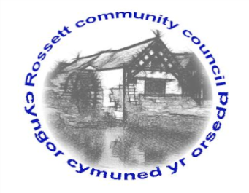

Rossett Community Council

13th February 2019

The next meeting of Rossett Community Council is to be held at Rossett Village Hall back room, Station Road, Rossett on Wednesday 20th February 2019 at 7.30pm to transact the following business.

Yours faithfully

Wendy Pace
Clerk for the Council

AGENDA

Declarations of Interest
Members are reminded that they should declare the existence and nature of any personal or prejudicial interest in the business of this meeting.

- Apologies for absence.

- Approval of the Minutes of the 16th January 2019 meeting

- Police Report.

- Representation's from General Public

Presentation from Gemma Rose, River Wellbeing Project Officer, North Wales Wildlife Trust – Invasive Non-Native Species

5. Matters arising:
- Burton CCTV - Clerk
- North East Wales Digital Trail – Cllr Pretsell
- Community Defibrillator – Clerk
- Street Lighting LED conversion – Clerk
- Community Councillor Vacancy - Clerk

6. Matters to be discussed:
- Internal Audit – Clerk
- WCBC Playground SLA – Clerk
- Community Awards – Cllr Pretsell
- Planning Strategy – Cllr Jones
- RCC Policies – Clerk
- Ground maintenance contract - Clerk

7. Reports : To receive updates from the following:
- County Councillor Jones’ Report
- Clerk’s Report
- Reports from Community Councillors

8. Planning:

P/2019/0033 – Woodlands, Chester Road, Rossett – New Garden Building Including a Summerhouse, Shed and Sheltered Canopy

P/2019/0046 – Lodge Farm, Commonwood, Holt – Change of Use of Land from Agricultural to Use for Clay Pigeon Range in Association with Field and Falcon Gun Shop and Gunsmiths (In Retrospect)

P/2019/0109 – Haytor 4 Park Lane Court, Rossett – Two-Storey Side Extension, Car Port with Roof Terrace Over, Erection of Replacement Garage/Outbuilding and New Walls/Gates to Entrance

9. Finance:
- Finance Report
- One Voice Wales membership
- Invoices payable (see attached schedule)
- Donation Requests

10. Other Items brought to the Council’s Attention by Councillors

11. Date, Venue and Time of next meeting: Wednesday 20th March 2019 at 7.30pm at Rossett Presbyterian Church meeting room, Station Road.
_____________________________________________________________
Clerk : Wendy Pace : clerk@rossettcommunitycouncil.cymru
Telephone: 07421 261118

