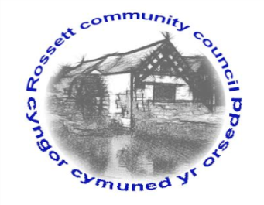

Rossett Community Council

11th April 2019

The next meeting of Rossett Community Council is to be held at Rossett Village Hall back room, Station Road, Rossett on Wednesday 17th April 2019 at 7.30pm to transact the following business.

Yours faithfully

Wendy Pace
Clerk for the Council

AGENDA

Declarations of Interest
Members are reminded that they should declare the existence and nature of any personal or prejudicial interest in the business of this meeting.

- Apologies for absence.

- Approval of the Minutes of the 20th March 2019 meeting

- Police Report.

- Representation's from General Public

5. Matters arising:
- Planning Strategy – Cllr Cleaver/Jones
- Cooks Bridge – Cllr Jones
- Community Defibrillator/training – Clerk
- Street Lighting LED conversion – Clerk

6. Matters to be discussed:
- Community Council contact – Clerk
- Chester Road footpath changes – Cllr Parrington
- Confirmation of roles to be filled at May meeting – Clerk
- Community Agent contract - Clerk

7. Reports : To receive updates from the following:
- County Councillor Jones’ Report
- Clerk’s Report
- Reports from Community Councillors

8. Planning:

P/2018/0685 – East View, Cobblers Lane, Burton – Amended plans for Steel Portal Framed Agricultural Livestock Building

P/2019/0240 – 1 The Limes, Chester Road, Rossett – Application for Tree Works subject to TPO – T2 Horse Chestnut – Crown reduce the top-heavier section of the tree by 3m.

P/2019/0241 – Rossett Court, Chester Road, Rossett – Removal of 1 Yew Tree within Conservation Area, Located in left of driveway (to facilitate new drive surface) and replanting of suitable replacement tree.

P/2019/0244 – Mount Alyn Gatehouse, Croeshowell Hill, Burton – Application for Variation of Condition 2 Imposed under Planning Permission P/2017/0935 to Allow Amendments to Approved Drawings to Allow for a Rear Flat Roof Full Width Dormer Extension.

P/2019/0246 – Gamford House, Gamford Lane, Rossett – Change of Use, Conversion and Replacement Agricultural Barns and Farmhouse to Form 8 No. Detached Dwelling Houses Including Removal of Derelict Structures Across the Site.

9. Finance:
- Finance Report
- Invoices payable (see attached schedule)

10. Other Items brought to the Council’s Attention by Councillors

11. Date, Venue and Time of next meeting: Wednesday 15th May 2019 at 7.30pm at Rossett Presbyterian Church meeting room, Station Road.
_____________________________________________________________
Clerk : Wendy Pace : clerk@rossettcommunitycouncil.cymru
Telephone: 07421 261118

