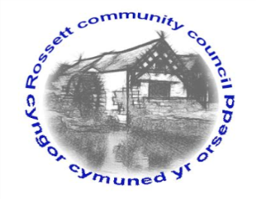

Rossett Community Council

10th May 2019

The next meeting of Rossett Community Council is to be held at Rossett Presbyterian meeting room, Station Road, Rossett on Wednesday 15th May 2019 at 7.30pm to transact the following business.

Yours faithfully

Wendy Pace
Clerk for the Council

AGENDA

Declarations of Interest
Members are reminded that they should declare the existence and nature of any personal or prejudicial interest in the business of this meeting.

- Apologies for absence.

- Approval of the Minutes of the 17th April 2019 meeting.

- Police Report.

- Appointment of Officers
(i) Chair
(ii) Vice Chair
(iii) Floods Partnership
(iv) Recreation Grounds Committee
(v) Finance Committee
(vi) Staffing Committee
(vii) Planning Committee
(viii) Fetes & Festivals Committee
(ix) Wrexham Town & Communities Forum
(x) One Voice Wales Representative
(xi) St Peters School Governor

5. Representation's from General Public

6. Matters arising:
- Planning Strategy – Cllr Cleaver/Jones
- Policy Review (Standing Orders/Facebook Policy) - Clerk
- GDPR – Community Councillors email addresses

7. Matters to be discussed:

- Disputed co-option – Cllr Parrington/Electoral monitoring/OVW
- Recreational areas – Cllr Cleaver

8. Reports : To receive updates from the following:

- County Councillor Jones’ Report
- Clerk’s Report
- Reports from Community Councillors

9. Planning:

P/2019/0338 – Woodlands, Chester Road, Rossett – Proposed New Garden Building to Include Summer House, Shed and Sheltered Canopy.

10. Finance:
- Finance Report
- Invoices payable (see attached schedule)

11. Other Items brought to the Council’s Attention by Councillors

12. Date, Venue and Time of next meeting: Wednesday 19th June 2019 at 7.30pm at Rossett Village Hall back room, Station Road.
_____________________________________________________________
Clerk : Wendy Pace : clerk@rossettcommunitycouncil.cymru
Telephone: 07421 261118

