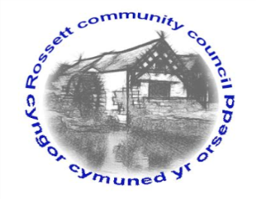

Rossett Community Council

11th July 2019

The next meeting of Rossett Community Council is to be held at Rossett Presbyterian Church meeting room, Station Road, Rossett on Wednesday 17th July 2019 at 7.30pm to transact the following business.

Yours faithfully

Wendy Pace
Clerk for the Council

AGENDA

Declarations of Interest
Members are reminded that they should declare the existence and nature of any personal or prejudicial interest in the business of this meeting.

- Apologies for absence.

- Approval of the Minutes of the 19th June 2019 meeting.

- Police Report.

- Representation's from General Public

- Matters Arising

- Recreational Areas – Cllr Cleaver
- Planning Strategy – Cllr Cleaver/Jones
- Toilet Block Development/Community Hub – Clerk/Cllr Parrington
- Village Festival – Volunteers for Stand – Cllr Parrington

6. Matters to be discussed:

- Rossett Playground CCTV – Clerk/Cllr Pretsell
- Wild Seed planting – Cllr Parrington

7. Reports : To receive updates from the following:

- County Councillor Jones’ Report
- Clerk’s Report
- Reports from Community Councillors

8. Planning:

P/2019/0457 – 7 Shordley Close, Rossett – Two Storey Side and Single Storey Rear Extension to Dwelling.

P/2019/0520 – 5 Shordley Close, Rossett – Two Storey Side Extension to Include New Entrance, Office Space and Utility Room to Ground Floor with Extended Master Bedroom and En-Suite to First Floor.

9. Finance:
- Finance Report
- Invoices payable (see attached schedule)

10. Other Items brought to the Council’s Attention by Councillors

11. Date, Venue and Time of next meeting: Wednesday 21st August 2019 at 7.30pm at Rossett Village Hall back room, Station Road.
_____________________________________________________________
Clerk : Wendy Pace : clerk@rossettcommunitycouncil.cymru
Telephone: 07421 261118

