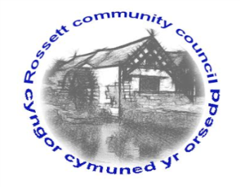

Rossett Community Council

12th June 2019

The next meeting of Rossett Community Council is to be held at Rossett Village Hall back room, Station Road, Rossett on Wednesday 19th June 2019 at 7.30pm to transact the following business.

Yours faithfully

Wendy Pace
Clerk for the Council
AGENDA

Declarations of Interest
Members are reminded that they should declare the existence and nature of any personal or prejudicial interest in the business of this meeting.

- Apologies for absence.

- Approval of the Minutes of the 15th May 2019 meeting.

- Police Report.

- Representation's from General Public

- Matters Arising

- Burton CCTV - Clerk
- Street Lighting LED Conversion – Clerk
- Chester Road/Holt Road junction – Cllr Maurice-Jones
- Recreational Areas – Cllr Cleaver
- Planning Strategy – Cllr Cleaver/Jones

6. Matters to be discussed:

- Disputed Co-option – Cllr Parrington
- Committees Terms of Reference – Clerk
- CPR Training – Clerk
- Community Agent Scheme – Clerk
- Village Stores Closure – Cllr Morris
- Dangerous traffic junctions – Cllr Steven

7. Reports : To receive updates from the following:

- County Councillor Jones’ Report
- Clerk’s Report
- Reports from Community Councillors

8. Planning:

P/2019/0339 – Grove House, Llyndir Lane, Burton – Application for the Variation of Conditions 2 and 3 of Planning Permission P/2017/0501 to allow the Roofing Material to be Changed from Western Cedar Vertical Timber Roof Cladding to Spanish Natural Blue Slate Roof Tiles to Match Existing Building in the Area.

P/2019/0460 – Land North and South of Lane Farm, Rossett Road, Trevalyn, Rossett – Outline Planning Application for Residential Development of Two Parcels of Land (Northern Parcel for up to 61 No. Dwellings, Southern Parcel for up to 71 No. Dwellings). Resubmission of Planning Application Reference No. P/2018/0560.

9. Finance:
- Finance Report – Risk Assessments
- Invoices payable (see attached schedule)
- Internal/External Audit

10. Other Items brought to the Council’s Attention by Councillors

Village Festival Signs – Rossett Playground

11. Date, Venue and Time of next meeting: Wednesday 17th July 2019 at 7.30pm at Rossett Presbyterian Church meeting room, Station Road.
_____________________________________________________________
Clerk : Wendy Pace : clerk@rossettcommunitycouncil.cymru
Telephone: 07421 261118

