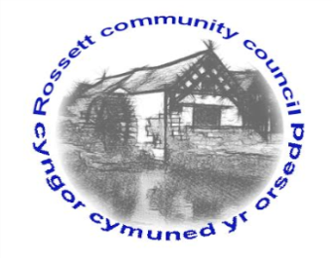
y

Rossett Community Council

15th August 2019

The next meeting of Rossett Community Council is to be held at Rossett Village Hall back room, Station Road, Rossett on Wednesday 21st August 2019 at 7.30pm to transact the following business.

Yours faithfully

Wendy Pace
Clerk for the Council

AGENDA

Declarations of Interest
Members are reminded that they should declare the existence and nature of any personal or prejudicial interest in the business of this meeting.

- Apologies for absence.

- Approval of the Minutes of the 17th July 2019 meeting.

- Police Report.

- Representation's from General Public

- Matters Arising

- Village Festival/Community Awards – Cllr Maurice-Jones/Clerk

6. Matters to be discussed:

- Wild Seed planting – Cllr Parrington
- Disclosure – Cllr Parrington
- ASB Village Discussion – Cllr Parrington
- Community café transport – Cllr Maurice-Jones

7. Reports : To receive updates from the following:

- County Councillor Jones’ Report
- Clerk’s Report

- Reports from Community Councillors

8. Planning:

P/2019/0560 – Land to North and South of Lane Farm, Rossett Road, Trevalyn, Rossett – Section 78 Appeal.

P/2019/0566 – The Lodge, 1 Strathalyn, Rossett – Application to Remove 1 No. Oak Tree Subject to TPO.

P/2019/0574 – 3 The Smithy, Chester Road, Rossett – Single-Storey Extension to Detached Bungalow.

P/2019/0624 – Verona Cottage, Chapel Lane, Rossett – Rear Extension

9. Finance:
- Finance Report
- Invoices payable (see attached schedule)

10. Other Items brought to the Council’s Attention by Councillors

11. Date, Venue and Time of next meeting: Wednesday 18th September 2019 at 7.30pm at Rossett Presbyterian Church meeting room, Station Road.
_____________________________________________________________
Clerk : Wendy Pace : clerk@rossettcommunitycouncil.cymru
Telephone: 07421 261118

