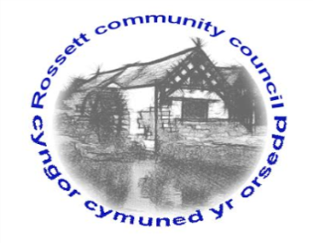

Rossett Community Council

13th September 2019

The next meeting of Rossett Community Council is to be held at Rossett Presbyterian Church meeting room, Station Road, Rossett on Wednesday 18th September 2019 at 7.30pm to transact the following business.

Yours faithfully

Wendy Pace
Clerk for the Council

AGENDA

Declarations of Interest
Members are reminded that they should declare the existence and nature of any personal or prejudicial interest in the business of this meeting.

- Apologies for absence.

- Approval of the Minutes of the 21st August 2019 meeting.

- Police Report.

- Representation's from General Public

- Matters Arising

- Storm Drains – Cllr Jones
- Cooks Bridge – Cllr Jones
- Chester Road/Holt Road junction – Cllr Morris
- Planning – Cllr Cleaver

6. Matters to be discussed:

- Hwb Yr Orsedd Budget – Clerk
- Christmas Tree Light Switch On - Clerk
- Burton CCTV IT – Clerk
- Donations – Clerk
- Tree donation – Clerk

7. Reports : To receive updates from the following:

- County Councillor Jones’ Report
- Clerk’s Report
- Reports from Community Councillors

8. Planning:

P/2019/0582 – Broad Oak Farm, Llyndir Lane, Rossett – Two-Storey Extension and Erection of Garage/Car-port.

P/2019/0635 – Trevalyn Hall, Darland Lane, Rossett – Construction of Stables to Include Loose Boxes, Tack Rooms and Hay Feed Store and Construction of Menage.

P/2019/0681 – Darland Croft, Darland Lane, Rossett – Change of Use of Implement/Tractor Store to a Research and Development Office/Workshop (B1 Use) Including Extension to Existing Dwelling.

P/2019/0702 – Huskissons House, Chester Road, Lavister – Application for Works to Trees Subject to Woodland Tree Preservation Order WCBC No. 179.

P/2019/0705 – Darland Barn, Darland Lane, Rossett – Erection of New Replacement Garage.

9. Finance:
- Finance Report
- Invoices payable (see attached schedule)

10. Other Items brought to the Council’s Attention by Councillors

11. Date, Venue and Time of next meeting: Wednesday 16th October 2019 at 7.30pm at Rossett Village Hall back room, Station Road.
_____________________________________________________________
Clerk : Wendy Pace : clerk@rossettcommunitycouncil.cymru
Telephone: 07421 261118

