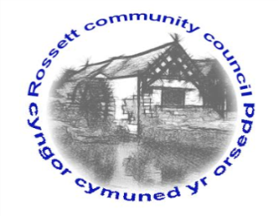

Rossett Community Council

10th October 2019

The next meeting of Rossett Community Council is to be held at Rossett Village Hall back room, Station Road, Rossett on Wednesday 16th October 2019 at 7.30pm to transact the following business.

Yours faithfully

Wendy Pace
Clerk for the Council

AGENDA

Declarations of Interest
Members are reminded that they should declare the existence and nature of any personal or prejudicial interest in the business of this meeting.

- Apologies for absence.

- Approval of the Minutes of the 18th September 2019 meeting.

- Police Report.

- Representation's from General Public

- Matters Arising

- Storm Drains – Cllr Jones
- Chester Road/Holt Road junction
- Holt Road parking - Clerk

6. Matters to be discussed:

- Hwb Yr Orsedd – Clerk
- Remembrance Parade
- Christmas Tree Light Switch On
- Street Lighting Maintenance Contract – Cllr Woods
- Updated Financial Regulations – Cllr Woods

7. Reports : To receive updates from the following:

- County Councillor Jones’ Report
- Clerk’s Report
- Reports from Community Councillors

8. Planning:

P/2019/0702 – Huskissons House, Chester Road, Lavister – Application for Works to Trees Subject to Woodland Tree Preservation Order WCBC No. 179.

P/2019/0742 – Trevalyn Wood, Manor Lane, Rossett – Listed Building Consent for Single Storey Extension to Dwelling, Internal and External Alterations to Existing Listed Buildings, Erection of Single-Storey Building to House Renewable Energy Store and Landscaping Works.

P/2019/0743 – Trevalyn Wood, Manor Lane, Rossett – Single Storey Extension to Dwelling, Internal and External Alterations to Existing Listed Buildings, Erection of Single-Storey Building to House Renewable Energy Store and Landscaping Works.

P/2019/0763 – Broad Oak Farm, Llyndir Lane, Rossett – Two-Storey Extension and Erection of Garage/Car-Port

9. Finance:
- Finance Report
- External Audit
- Invoices payable (see attached schedule)

10. Other Items brought to the Council’s Attention by Councillors

11. Date, Venue and Time of next meeting: Wednesday 20th November 2019 at 7.30pm at Rossett Village Hall back room, Station Road.
_____________________________________________________________
Clerk : Wendy Pace : clerk@rossettcommunitycouncil.cymru
Telephone: 07421 261118

