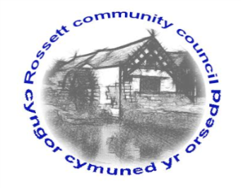

Rossett Community Council

12th December 2019

The next meeting of Rossett Community Council is to be held at Rossett Village Hall back room, Station Road, Rossett on Wednesday 18th December 2019 at 7.30pm to transact the following business.

Yours faithfully

Wendy Pace
Clerk for the Council

AGENDA

Declarations of Interest
Members are reminded that they should declare the existence and nature of any personal or prejudicial interest in the business of this meeting.

- Apologies for absence.

- Approval of the Minutes of the 20th November 2019 meeting.

- Police Report.

- Representation's from General Public

- Matters Arising

- Hwb Yr Orsedd lease of building - Clerk
- Street Lights additional works - Clerk

6. Matters to be discussed:

- Shaping the Future of Wrexham Library Service – Clerk
- Purchase of bins – Clerk

7. Reports: To receive updates from the following:

- County Councillor Jones’ Report
- Clerk’s Report
- Reports from Community Councillors

8. Planning:

P/2019/0868 – West Darland Hall, Darland Lane, Rossett – Application for Listed Building for the Removal of Load Bearing Walls in the Ground and First Floor Levels, Creation of New Door Opening in the Load Bearing Wall of the Ground Floor, Relocation of the Kitchen within the Property and Refurbishment of Sash Windows and Replacement of French Doors.

P/2019/0886 – 3 Park Lane Court, Rossett – Installation of New Window to Front Elevation.

9. Finance:
- Finance Report
- Precept
- Invoices payable (see attached schedule)

10. Other Items brought to the Council’s Attention by Councillors

11. Date, Venue and Time of next meeting: Wednesday 15th January 2020 at 7.30pm at Rossett Presbyterian Church meeting room, Station Road.
_____________________________________________________________
Clerk : Wendy Pace : clerk@rossettcommunitycouncil.cymru
Telephone: 07421 261118

