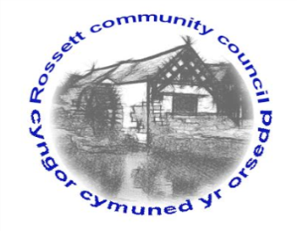

Rossett Community Council

14th November 2019

The next meeting of Rossett Community Council is to be held at Rossett Presbyterian Church meeting room, Station Road, Rossett on Wednesday 20th November 2019 at 7.30pm to transact the following business.

Yours faithfully

Wendy Pace
Clerk for the Council

AGENDA

Declarations of Interest
Members are reminded that they should declare the existence and nature of any personal or prejudicial interest in the business of this meeting.

- Apologies for absence.

- Approval of the Minutes of the 16th October 2019 meeting.

- Police Report.

- Representation's from General Public

- Matters Arising

- Hwb Yr Orsedd
- Traffic Flow around The Green

6. Matters to be discussed:

- Street Lighting Maintenance Contract Price Increase – Clerk
- Christmas Tree Light Switch On
- Purchase of street Warden equipment – Clerk
- Purchase of mobile phones – Clerk
- Road junction Croeshowell Lane/Llay Road

7. Reports: To receive updates from the following:

- County Councillor Jones’ Report
- Clerk’s Report
- Reports from Community Councillors

8. Planning:

Consultation – Meadow House, Trevalyn, Rossett – Woodland creation project.

P/2019/0846 – 2 Darland Close, Rossett – Single-Storey Side Extension, Demolition of Conservatory and New Single-Storey Rear Extension, First Floor Extension and Internal Alterations.

9. Finance:
- Finance Report
- Donation Requests
- Invoices payable (see attached schedule)

10. Other Items brought to the Council’s Attention by Councillors

11. Date, Venue and Time of next meeting: Wednesday 18th December 2019 at 7.30pm at Rossett Village Hall back room, Station Road.
_____________________________________________________________
Clerk : Wendy Pace : clerk@rossettcommunitycouncil.cymru
Telephone: 07421 261118

