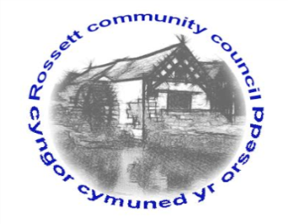

Rossett Community Council

13th February 2020

The next meeting of Rossett Community Council is to be held at Rossett Village Hall back room, Station Road, Rossett on Wednesday 19th February 2020 at 7.30pm to transact the following business.

Yours faithfully

Wendy Pace
Clerk for the Council
AGENDA

Declarations of Interest
Members are reminded that they should declare the existence and nature of any personal or prejudicial interest in the business of this meeting.

- Apologies for absence.

- Approval of the Minutes of the 15th January 2020 meeting.

- Police Report – revision to production of information.

- Representation's from General Public

- Matters Arising

- Hwb Yr Orsedd
- Contribution to OWL Cymru – Cllr Parrington
- Renewal of WCBC Dog Control and Dog Fouling Protection Order

6. Matters to be discussed:

- Volunteer Group – Cllr Cleaver
- VE Day Event – Cllr Fortune
- Clearing of ditches – Cllr Pretsell

7. Reports: To receive updates from the following:

- County Councillor Jones’ Report
- Clerk’s Report
- Reports from Community Councillors

8. Planning:

P/2019/0909 – Three Acres, Rosemary Lane, Burton – Application for Variation of Condition No. 2 Imposed Under Planning Permission P/2018/0904 to Vary the Designs of the Extensions and of the Materials to be used.

P/2020/0022 – 1 Beech Hollows, Rossett – Incorporation of Land into Residential Curtilage and Erection of 2m High Boundary Wall.

P/2020/0101 – 14 Stonewalls, Burton, Rossett – Works to Trees Subject to Tree Preservation Order WCBC 51, Reduce Height of 1 Ash by up to 5 M.

9. Finance:
- Finance Report hy
- Invoices payable (see attached schedule)

10. Other Items brought to the Council’s Attention by Councillors

11. Date, Venue and Time of next meeting: Wednesday 18th March 2020 at 7.30pm at Rossett Presbyterian Church meeting room, Station Road.
_____________________________________________________________
Clerk : Wendy Pace : clerk@rossettcommunitycouncil.cymru Tel: 07421 261118

