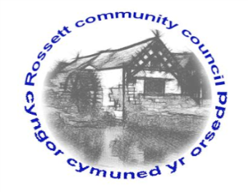

Rossett Community Council

12th May 2020

The next meeting of Rossett Community Council is to be held via video conferencing on Wednesday 17th June 2020 at 7.30pm to transact the following business.

Yours faithfully

Wendy Pace
Clerk for the Council
AGENDA

Declarations of Interest
Members are reminded that they should declare the existence and nature of any personal or prejudicial interest in the business of this meeting.

- Apologies for absence.

- Review of the Minutes of the 20th May 2020 meeting.

- Representation's raised by General Public

- Matters Arising

- Sewing for our NHS
- PPE donation bid

- Matters to be discussed:

- Councillor Vacancy
- Water connection
- Wild flower garden

6. Reports: To receive updates from the following:

- County Councillor Jones’ Report
- Clerk’s Report
- Reports from Community Councillors

7. Planning:

8. Finance:
- Finance Report
- Invoices payable (see attached schedule)
- External Audit – Annual Review
- Risk Assessments

9. Other Items brought to the Council’s Attention by Councillors

10. Date and Time of next meeting: Wednesday 15th July 2020 at 7.30pm via video conferencing.
_____________________________________________________________
Clerk : Wendy Pace : clerk@rossettcommunitycouncil.cymru Tel: 07421 261118

Due to Covid 19 a public meeting cannot be held. Members of the community are invited to forward any issues for discussion via email or telephone to the Clerk. All non-emergency issues have been deferred initially for a period of three months.
If you would like to view the meeting, please email the Clerk to request the meeting ID.

