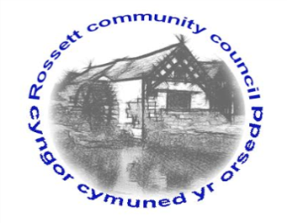

Rossett Community Council

12th March 2020

The next meeting of Rossett Community Council is to be held at Rossett Presbyterian Church meeting room, Station Road, Rossett on Wednesday 18th March 2020 at 7.30pm to transact the following business.

Yours faithfully

Wendy Pace
Clerk for the Council
AGENDA

Declarations of Interest
Members are reminded that they should declare the existence and nature of any personal or prejudicial interest in the business of this meeting.

- Apologies for absence.

- Approval of the Minutes of the 19th February 2020 meeting.

- Police Report.

- Representation's from General Public

- Matters Arising

- Hwb Yr Orsedd
- VE Day Event – Cllr Parrington/Fortune
- Public Rights of Way – Cllr Maurice-Jones
- Electoral Boundary Proposal – Cllr Jones
- Clearing of ditches/flooding Burton – Cllr Jones

6. Matters to be discussed:

7. Reports: To receive updates from the following:

- County Councillor Jones’ Report
- Clerk’s Report
- Reports from Community Councillors

8. Planning:

P/2020/0114 – Three Oaks, Chester Road, Rossett – Application for Works to Tree Subject to Tree Preservation Order WCBC No. 55 – Reduce Lower Third f Crown back to Suitable Growth Points in-line with Boundary Fence – Crown Raise over Garden only to Provide 6.0 Clearance as agreed with the Tree Officer.

9. Finance:
- Finance Report
- Invoices payable (see attached schedule)
- Internal Audit

10. Other Items brought to the Council’s Attention by Councillors

11. Date, Venue and Time of next meeting: Wednesday 15th April 2020 at 7.30pm at Rossett Village Hall back room, Station Road.
_____________________________________________________________
Clerk : Wendy Pace : clerk@rossettcommunitycouncil.cymru Tel: 07421 261118

